**Languages Page**

Menu (Home / About us / Services / Languages / Quality / Industries / Blogs / Contact us

13+ Years of Extensive Industry Experience *( It has to come in all the pages above the H1)*

**Language Translation Services in India**

All Indian & International Languages Translation and Localization - Fast, Reliable, Affordable!!

We provide complete Language solutions at single point

to save your time and money.  Look no further?

*( will remain same in all the pages- pls chk if u can change the design)*

We are India's leading professional translation service provider. We Feenix Language Solution an Award Winning Company **INDIA 5000 BEST MSME AWARDS / ISO 9001:2015 Certified** established as translation industry leader. Since 2011, 13+ years of extensive industry knowledge.

We have our headquarters in Bangalore, India and have been a part of this community for over the years. We understand that each project is unique and requires a tailored approach based on the needs of our clients.

* ISO 9001:2015: We are proud to be ISO 9001:2015 certified
* Award-Winning Excellence: India Best 5000 MSME Award - Our commitment to quality & customer satisfaction
* Established in 2010: 13+ glorious years of experience, Industry knowledge
* Domain Specialized Linguists: 1000+ Linguists with high-quality translation services
* Advanced Technology: Leverage the power of cutting-edge translation tools

Indian Languages Translation Services *should comes like a button*

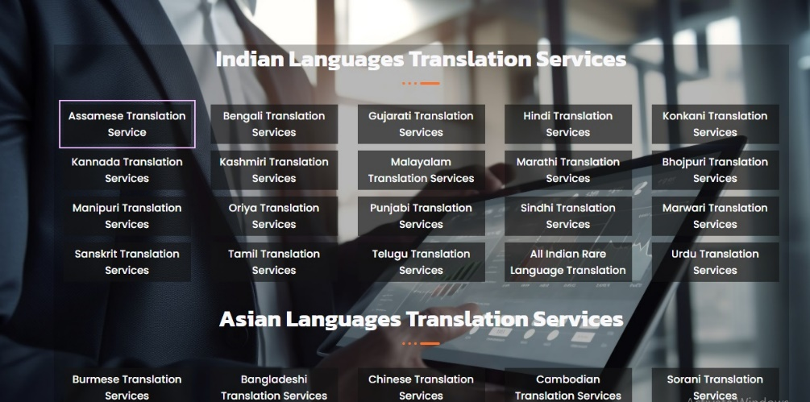

|  |  |  |  |  |
| --- | --- | --- | --- | --- |
|  |  |  |  |  |

* Assamese Translation Services
* Bengali Translation Services
* Gujarati Translation Services
* Hindi Translation Services
* Kannada Translation Services
* Kashmiri Translation Services
* Malayalam Translation Services
* Marathi Translation Services
* Manipuri Translation Services
* Oriya Translation Services
* Punjabi Translation Services
* Sindhi Translation Services
* Sanskrit Translation Services
* Tamil Translation Services
* Telugu Translation Services
* Tulu Translation Services
* Konkani Translation Services
* Bhojpuri Translation Services
* Marwari Translation Services
* Urdu Translation Services

###### ASIAN LANGUAGES

* Burmese Translation Services
* Bangladeshi Translation Services
* Chinese Translation Services
* Cambodian Translation Services
* Dari Translation Services
* Indonesian Translation Services
* Japanese Translation Services
* Khmer Translation Services
* Korean Translation Services
* Kurdish Translation Services
* Lao Translation Services
* Malay Translation Services
* Malagasy Translation Services
* Nepalese Translation Services
* Pashto Translation Services
* Singhalese Translation Services
* Sorani Translation Services
* Sylheti Translation Services
* Thai Translation Services

Vietnamese Translation Services

###### MIDDLE EAST & EASTERN EUROPEAN LANGUAGES

* Albanian Translations
* Arabic Translations
* Bulgarian Translations
* Croatian Translations
* Czech Translations
* Estonian Translations
* Farsi Translations
* Hebrew Translations
* Hungarian Translations
* Mongolian Translations
* Polish Translations
* Romanian Translations
* Russian Translations
* Serbian Translations
* Slovenian Translations
* Slovak Translations
* Tajik Translations
* Turkish Translations
* Ukrainian Translations

Uzbek Translations

###### EUROPEAN LANGUAGES

* Danish Translation Services
* Dutch Translation Services
* Finnish Translation Services
* French Translation Services
* Flemish Translation Services
* German Translation Services
* Greek Translation Services
* Icelandic Translation Services
* Italian Translation Services
* Maltese Translation Services
* Norwegian Translation Services
* Portuguese Translation Services
* Spanish Translation Services
* Castilian Spanish Translation Services
* Latin American Spanish Translations Services
* Swedish Translation Services

*( will remain same in all the pages- pls chk if u can change the design)*

why we are special

**Vast Network of skilled Multi Lingual Translators**

Feenix Language Solution enables thousands of Large, Medium and small companies to fuel their global growth with cost-effective professional translation & localization services.

|  |  |  |  |
| --- | --- | --- | --- |
| A Creative Human Touch  Looking for translation services that deliver exceptional quality and accuracy? Look no further than our Professional Translation services with a creative human touch! We translator helps you to communicate through your language. | We are Since 2010  We understand that your words are personal and important, which is why we make sure they stay in human hands from beginning to end. Our team of expert translators will carefully localize and approve your web content, ensuring that there are no costly mistranslations that could cost you millions. | | A Translation Company You Can Trust  We guarantee the most accurate localization possible while helping you reduce costs. Plus, with our trust and commitment to maintaining your trust, you can rest assured that your words are in good hands. |
| Convenient & Accommodating  Our convenient and accommodating services make it easy to send and receive documents, pay, and get the results you need. Experience the difference of translation services with a creative human touch! | | Affordable & Flexible Pricing  FLS provides a comprehensive solution for all your language translation needs. We have a flexible pricing plan to meet all types of content requirements and budgets. You have the freedom to customize your wants. | |

WHAT WE DO

Specially Designed Project Management for Your Online Store

Translation strategy requires planning to ensure your project goes smoothly. After defining your business needs and target languages, we work with you to create a detailed project plan and workflow that guarantees completion according to your specifications and expectations.

* Extracting all relevant similar text
* Estimation of word counts, costs and turnaround times
* Repeated words glossary and style guide
* Creating of a client-specific translation memory (TM) to store all translated content

**Professional human translation**

* 20,000+ translators in almost every country working with different domains.
* Fastest turnaround times in the industry.
* High quality human translation at affordable price.

**Project management system (PMS)**

* Automates much of the translation process.
* Get a clear view of project process, customizable dashboards and daily reports.
* Managing projects, keeping track of all project status.

**Localization project management**

* End-to-end translation project management to ensure every phase of your project is completed with high accuracy
* Experienced dedicated project managers will ensure your project is delivered on time and according to your specifications
* Customized plans according to your requirement & timelines

*Know More About Quality Process (Button)*

***Multi-format Support***

Get your technical and engineering documents translated and delivered in any format of your choice through our CAD / Desktop Publishing (DTP) Services.

***Quality Assurance***

We ensure high quality translated documents through our quality control procedures and your technical content is translated with precision, accuracy, and consistency.

***Affordable Prices & 24/7***

Avail market-competitive and affordable rates for your Technical document translations. Guarantee round-the-clock translation and consultation support.

***Quick Turn-around***

With our quick turnaround times, you can rest assured that your message will be communicated to your target audience in a timely manner. Choose our Certificate Translation & Attestation services for a flawless translation experience.

*( will remain same in all the pages- pls chk if u can change the design)*

**Key Benefits working with Feenix Language Solution**

With our expertise in translating and localizing content, we help you break down these barriers and reach out to customers worldwide.

|  |  |  |
| --- | --- | --- |
| Expand Your Global Reach  Expand your business and increase sales potential by making your website visible to a global market. With Feenix's Translation services, you can easily expand your reach and connect with diverse markets worldwide. | Exceptional User Experience  Deliver an enhanced user experience by providing translated content in your target audience's local language. With our in- dustry specific knowledge, process and technology expertise and customer experience. | Branding Consistency for All Your Products  Your brand's voice, tone & brand identity remains consistent in all the content in any language we translate. You can touch your target audience and attract potential customers, also establish trust & loyalty. |
| SEO Content and More Visibility  Translated & SEO optimized content boosts your search engine visibility in Inter- national markets. We have proven that a combined holistic multilingual approach, substantially increases online traffic. | Higher Rate of Conversion  Customer friendly local language with local essence makes easier customers to purchase, they can access product information, reviews and customer support in their native language. | Localization & Cultural Sensitivity  Design to cater cultural sensitivity beyond just language. Ensuring that images, symbols, color & other sensitive elements tailored to resonate with target audience, enhancing user satisfaction. |

Updated with Current Trends

**Unlock the Power of Advanced Translation Technologies**

We have developed our own translation technologies, such as our real-time translation memory and interactive glossary, which significantly optimize the total number of words to translate.

Our technology also ensures the consistency of your translations, while integrating your SEO keywords in every language. We have also integrated leading-edge neural machine translation that helps to reduce translations costs even more.

* Source documents will be received by PM
* Preparing checklist with necessary instructions to translators
* Best Possible Timeline confirmation
* Proofing with In-house specialist
* DTP, checking for fonts, layout against English source
* Translation will be validated by an alternative translator
* Finalizing the templates

Know More About Quality Process (Button link)

SEO-Friendly Content Optimization

**Optimized Content for Your Local & International SEO**

Localization in fluent Local language

Our team of SEO experts are here to save your day. We'll take your content with complete SEO support. We'll optimize your content in all languages and on all search engines, so you can be sure that your message is getting heard loud and clear. We cover your project with our top-notch translation skills. Trust us, your online visibility will be so high, you'll practically be able to touch the sky. So why wait? Let's get optimizing!

Meets the Industry Standard

Simple Process with dedicated Project Manager- you can communicate with our project manager at any point. Just share your materials with our dedicated project manager, provide details about your project, and leave the rest to us.

Boost Brand Image with Social Engagement

Prioritizing your International customers with professional localization will also increase downloads and reduce the risk of plagiarism. Plus, it will boost your brand image by avoiding offensive content. So don't miss out on the benefits of video game localization - let us help you take your game to new heights!

Worldwide Experience

**We Always Try to Understand Users Expectation**

Our native speakers in the target languages are well-versed in the legal terminology and jargon specific to their respective countries. Trust us to provide you with high-quality legal translation services that meet your unique needs and requirements.

|  |  |  |  |
| --- | --- | --- | --- |
| 27.4K +  Happy Clients | 10K+  Translators | 116 +  Languages | 60M+  Words translated |

Affordable & Flexible Pricing

We have a flexible pricing plan to meet all types of content requirements and budgets. You have the freedom to customize your requirements.

__________________ Email Us

**Industries We Serve:**

We work hard creating new and innovative localized content in local language concepts unique to the brands we promote, with high production values that match our clients’ expectations. We have a legacy of great localization & translation services that have been used to help promote campaigns worldwide.

**below all should comes with buttons (it repates in home page, languages, industries, contact us)**

|  |  |  |  |  |
| --- | --- | --- | --- | --- |
| Agriculture Translation Services | Administrative Translation Services | Academic Translation Services | Advertising Translation Services | Aeronautics Translation Services |
| Aerospace Translation Services | Architect Translation Services | Automobile Translation Services | Auto CAD Translation Services | Banking Translation Services |
| Biotechnology Translation Services | Bio chemistry Translation Services | Beauty Products Translation Services | Business Translation Services | Chemical Translation Services |
| Civil Engineering Translation Services | Defence Translation Services | Construction Translation Services | Consumer Translation Services | Cosmetics Translation Services |
| Contract Research Translation Services | Dairy Products Translation Services | Environmental Translation Services | Digital Marketing Translation Services | Documents Translation Services |
| E-Learning Translation Services | E-Commerce Translation Services | Electrical Engineering Translation Services | Electronics Engineering Translation Services | Education Translation Services |
|  |  |  |  |  |

Entertainment Translation Services

Fashion & Beauty Translation Services

Film / Movie Translation Services

Financial Translation Services

Gaming Translation Services

Government Translation Services

Governance Translation Services

Hospitality Translation Services

Import & Export Translation Services

Industrial Translation Services

Engineering Translation Services

Industrial manufacturing Translation Services

Information Science Translation Services

IT Translation Services

Life Science Translation Services

Logistics Translation Services

Marketing Translation Services

Manufacturing Translation Services

Media Translation Services

Food & Beverage Translation Services

Medical Devices Translation Services

Mining Translation Services

Multi Culture Marketing Translation Services

Oil & Gas Translation Services

Organic Products Translation Services

Organic Fertilizers Translation Services

Pharmaceutical Translation Services

Pharmacy Translation Services

Insurance Translation Services

Press Release Translation Services

Printing Translation Services

Private Sector Translation Services

Public Sector Translation Services

Publishing Translation Services

Railway Translation Services

Real Estate Translation Services

Retail Translation Services

Shipping Translation Services

Shopping Translation Services

Software Translation Services

Tele communication Translation

Television Translation Services

Textile Translation Services

Transportation Translation Services

Tourism Translation Services

**Footer it will come in all the pages**

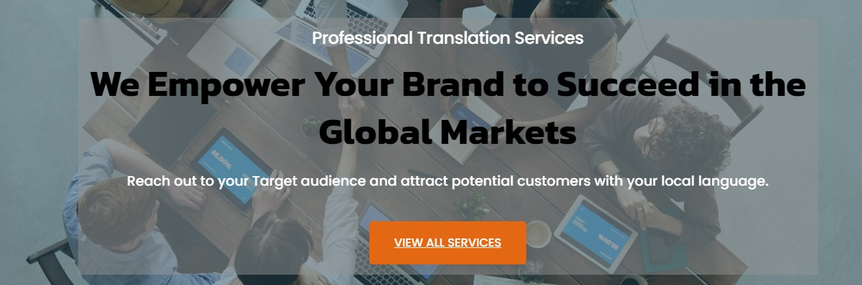

|  |  |  |  |
| --- | --- | --- | --- |
| * **Feenix Language Solution** * No.5, 2nd Floor, 5th Main, * KHM Block, R.T. Nagar, * Bengaluru - 560 032. * INDIA * Call @ **080-41244092 / 23332762 Mobile: 98453-72762** * info@feenixlanguage.com * www.feenixlanguage.com | * **Industries We Serve** * Automobile & Engineering * Business & Marketing * Banking & Finance * E-Commerce, E-Learning * Software & Hardware * Technical & Non-Technical * Legal, Industrial * Medical, Pharmaceutical etc., | * **Our Best Services:** * [Language Translation Services](http://localhost/Feenix/info@feenixlanguage.com) * [Language Localization Services](http://localhost/Feenix/info@feenixlanguage.com) * [Content Writing Services](http://localhost/Feenix/info@feenixlanguage.com) * [Multi Lingual Proof-Reading](http://localhost/Feenix/info@feenixlanguage.com) * [Multi Lingual Content Creation](http://localhost/Feenix/info@feenixlanguage.com) * [Voice-Over Services](http://localhost/Feenix/info@feenixlanguage.com) * [Video Editing & Sub-Titling](http://localhost/Feenix/info@feenixlanguage.com) * [Desktop Publishing Services](http://localhost/Feenix/info@feenixlanguage.com) | * **Quick Links**: * [Sitemap](http://localhost/Feenix/info@feenixlanguage.com) * [Latest Blogs](http://localhost/Feenix/info@feenixlanguage.com) * [Join Us](http://localhost/Feenix/info@feenixlanguage.com) * [Contact Us](http://localhost/Feenix/info@feenixlanguage.com) * [Customer Support](http://localhost/Feenix/info@feenixlanguage.com) * [FAQs](http://localhost/Feenix/info@feenixlanguage.com) * [Quality Process](http://localhost/Feenix/info@feenixlanguage.com) * [Privacy Policy](http://localhost/Feenix/info@feenixlanguage.com) |

Social media icons

copy rights / menu